Implement static routing using
4 routers and 8 pc
use ip from class A only starting from 10.0.0.0
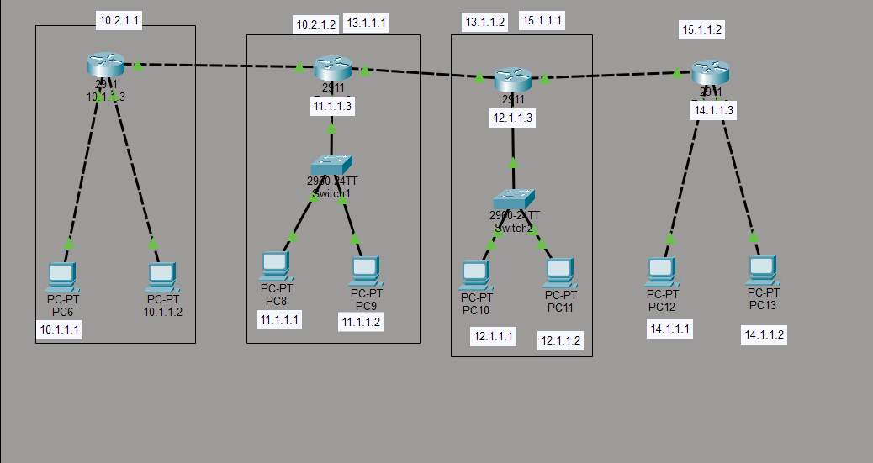
steps :
take 4 routers, 2 switch and 8 pc
connect them as shown in figure configure them (configure their ips and that’s all)
implement 3 vlan name HR ADMIN Finance and VLAN trunking using one switch and 6 pc
assign fa0/1 and fa0/2 to HR
assign fa0/3 and fa0/4 to admin
assign fa0/5 and fa0/6 to finance
and fa0/24 as trunk port

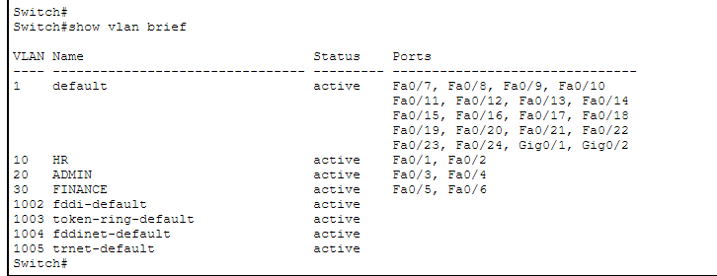

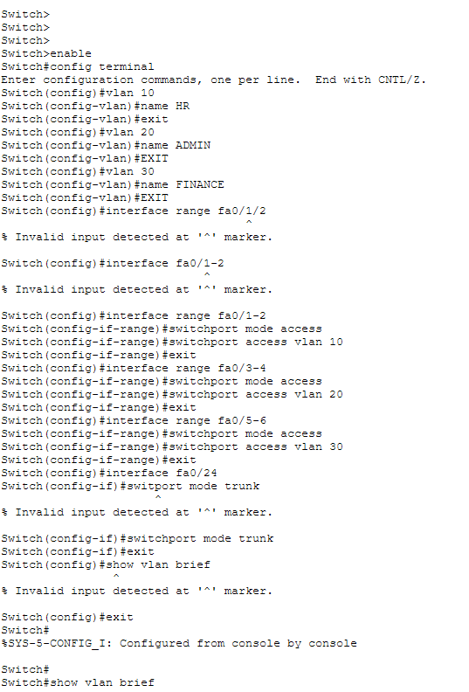

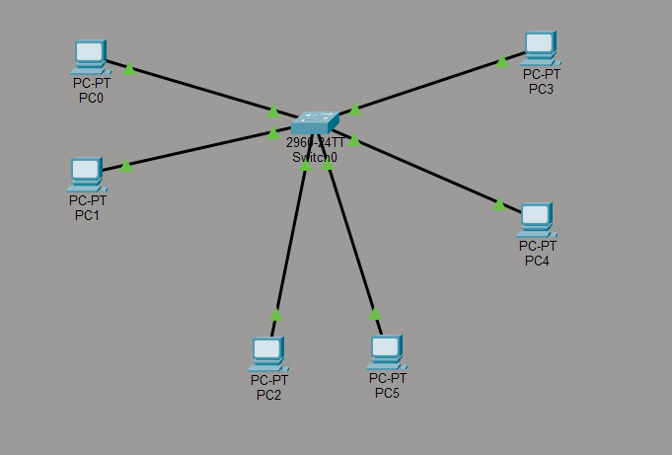

Steps
take 6 pc and 1 switch connect them as given in figure configure the pc (not shown in diagram so sorry for that )
and then run the command as shown in above screenshots and good to go

